RESOLUTION NO.__________

RE: CERTIFICATE OF APPROPRIATENESS UNDER THE
PROVISIONS OF THE ACT OF THE PENNSYLVANIA
LEGISLATURE 1961, JUNE 13, P.L. 282 (53
SECTION 8004) AND BETHLEHEM ORDINANCE NO.
3952 AS AMENDED.

WHEREAS, it is proposed to replace roof at 626 Evans Street,

NOW, THEREFORE, BE IT RESOLVED by the Council of the City of Bethlehem that a Certificate of Appropriateness is hereby granted for the work.

Sponsored by: (s)

(s)

ADOPTED BY COUNCIL THIS DAY OF

(s)
President of Council

ATTEST:

(s)
City Clerk

HISTORIC CONSERVATION COMMISSION

CASE # 558 – It is proposed to replace roof at 626 Evans Street
OWNER/APPLICANT: Jamie Dejesus / Heidi Westerman

The Commission upon motion by Mr. Roeder seconded by Mr. Evans adopted the proposal that City Council issue a Certificate of Appropriateness for the proposed work described herein:
- The proposal to replace roof at 626 Evans Street was presented by Heidi Westerman.
- The new section of architectural shingles installed as an emergency repair may remain in place.
- The architectural shingles replaced 3-tab shingles and were approved because the area where they were installed was at the rear of the house and had low visibility.
- The remainder of the roof must be replaced with GAF Slateline or CertainTeed Hatteras shingles in the Antique Slate or equivalent color.
- All valleys in the new roof are to be open and flashed with heavy gauge aluminum, copper, or lead coated copper flashing. The drip edges should be copper, lead coated copper or aluminum to match the color of the house trim.
- New gutters must be half round with round downspouts. The gutter and downspout may be aluminum.
- The proposed motion was unanimously approved.

CU: cu
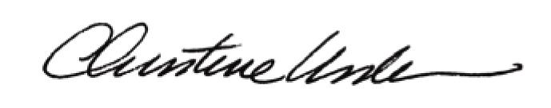

By:

Date of Meeting: July 20, 2015 Title: Historic Officer

